HTML & CSS

**Exercise 1: To design a webpage given to us through screenshots and make it responsive. Design its mobile site equivalent also(media queries).**

**Screenshots given to us for reference:**



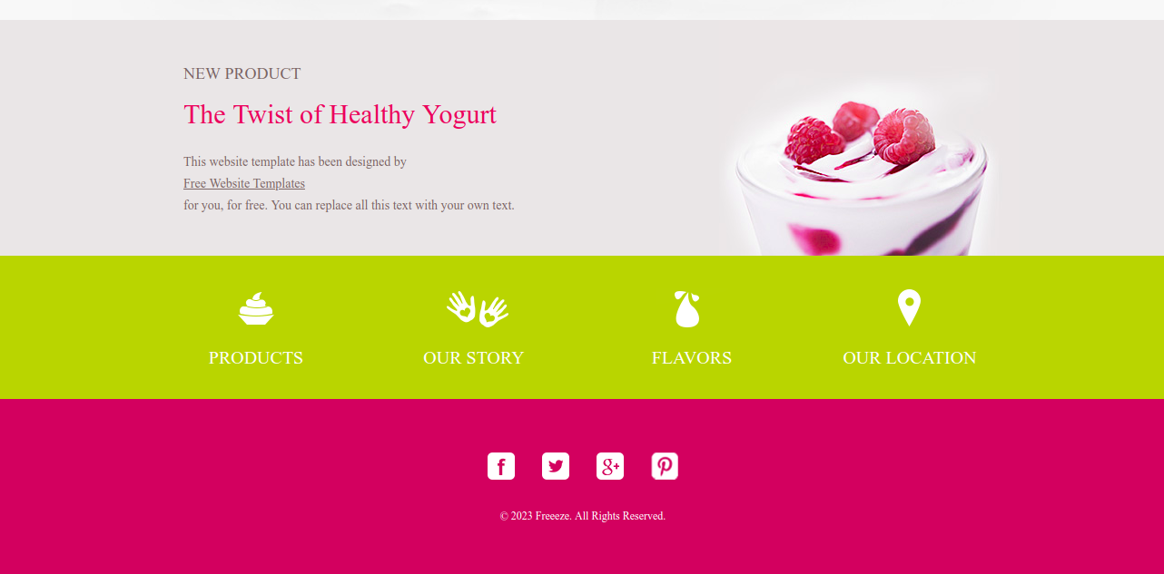



|  |  |
| --- | --- |
|  |  |

**Answer :** index.html attached in git repository.

P.s : I admit that this one has used crappy formatting design. It was our first session where were tried our hands on responsiveness and media queries and we got to know about concepts of using container or wrapper in later sessions that followed after this one where we improved further.

**Exercise 2: To create a circular loader using css animations.**

Answer : loader.html and loader.css attached in git repository